**Willetton Senior High School**

**Year 11 AEECO 2020**

**Assessment 4**

**Name:**

**Teacher: QUESTIONS Your Mark: _________/40**

**TYPE:** Short Answer

**OUTCOMES:** Outcome 1: Economic inquiry; Outcome 2: The operation of the economy

**WEIGHTING:** 7.5%

**CONTENT:** Market Failure

**Section 1:** Multiple Choice (10 marks)

**Section 2:** Short Answer (30 marks)

**Time allowed:** 50 minutes

**Conditions:**

This assessment is to be written in class without notes.

**SECTION 1: MULTIPLE CHOICE (10 marks)**

1. If the social cost of producing chicken is greater than the private cost, then we can be sure that
   1. a positive externality exists.
   2. chicken is healthy and more should be produced.
   3. a negative externality exists.
   4. the market for chicken is efficient.
2. Pollution is an example of market failure because
   1. the equilibrium price is higher than the socially optimal price.
   2. the equilibrium price is less than the socially optimal price.
   3. the market does not produce enough of the good.
   4. those who suffer from pollution are compensated outside the market.
3. In order for someone to be a free rider, an activity must be undertaken that
   1. arranges for ride-sharing at rush hour.
   2. creates benefits for people who can’t be forced to pay for them.
   3. beautifies the neighbourhood.
   4. identifies beneficiaries and forces them to pay.
4. All of the following are goods for which property rights are hard to identify except
   1. a river running along a field of corn.
   2. the atmosphere over a field of corn.
   3. crows that eat the corn on the field.
   4. a field of corn.
5. When there are negative externalities, the price should be adjusted so that it is equal to
   1. social cost.
   2. private cost.
   3. the amount of the externality.
   4. zero.
6. All of the following are ways to cope with negative externalities except
   1. public choice.
   2. quantity restrictions.
   3. pollution taxes.
   4. assigning property rights.
7. The private market will not provide enough of a public good because of
   1. negative externalities.
   2. obligatory controls over production methods.
   3. public choice not to produce the good.
   4. a free rider problem.
8. Governments try to control negative externalities to
   1. Improve resource allocation.
   2. Achieve a more equitable income distribution
   3. Achieve full employment and price stability
   4. Achieve sustainable economic growth.
9. The use of WA’s ground water supplies, such as the Gnangara Mound, need to be controlled because they are
   1. Public goods.
   2. Club goods.
   3. Common property resources.
   4. Merit goods.
10. Which of the following would be an effective response to the overuse of common access resources?
    1. The use of a sales tax on products made using the resource
    2. The introduction of additional government subsidies
    3. Raising profits tax on producers using the resource
    4. Assigning property rights over the common property resources.

**SECTION 2: SHORT ANSWER (30 marks)**

**Question 1- Market Power** (10 marks)

Refer to the article below to answer the questions that follow.

|  |
| --- |
| ****Consumer watchdog calls for new measures to combat Facebook and Google’s digital dominance**** July 26, 2019 4.22pm AEST  Authors: [**Rob Nicholls**](https://theconversation.com/profiles/rob-nicholls-91073) Senior lecturer in Business Law, UNSW  [**Katharine Kemp**](https://theconversation.com/profiles/katharine-kemp-402096) Senior Lecturer, Faculty of Law, UNSW, and Co-Leader  The Australian Competition and Consumer Commission (ACCC) has called for “[holistic, dynamic reforms](https://www.accc.gov.au/media-release/holistic-dynamic-reforms-needed-to-address-dominance-of-digital-platforms)” to address the online dominance of digital behemoths (extremely large and powerful company) such as Google and Facebook.  A [600-page report](https://www.accc.gov.au/publications/digital-platforms-inquiry-final-report), released today, makes 23 recommendations for regulating digital platforms – covering competition law, consumer protection, media regulation, and privacy.  Most of the suggested reforms are aimed squarely at countering the dominance of Facebook and Google, which the ACCC says has distorted a range of markets including advertising and media.  The ACCC recommends forming a new branch to deal specifically with Google and Facebook. But it doesn’t propose itself as the sole watchdog: the report also recommends a regulatory role for the Australian Communications and Media Authority ([ACMA](https://www.acma.gov.au/)).  Under the recommendations, ACMA would also be expected to monitor digital platforms’ efforts to identify reliable and trustworthy news, and to manage a mandatory take-down code for content that breaches copyright.  [www.accc.gov.au › anti-competitive-behaviour › misus...](http://www.accc.gov.au › anti-competitive-behaviour › misus...) |

1. Define the term market power. (1 mark)
2. What is an anti-competitive behaviour? Name one main type of anti-competitive behaviour used by firms in order to reduce competition. (2 mark)
3. Explain how the dominance of Google and Facebook results in an imperfect market and why is this market structure inefficient? (4 marks)
4. Describe the role of ACCC under the Australian Consumer Law. Identify one reform recommended by it in the article to deal with the market power of Google and Facebook. (3 marks)

**Question 2- Externalities** (10 marks)

This question refers to the diagram below, which shows the coal market.

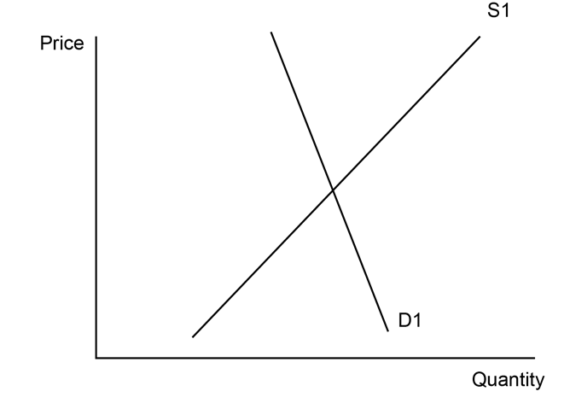

1. Label the initial market equilibrium price (P1) and quantity (Q1) on the diagram.

(1 mark)

1. Explain why this negative externality is not initially considered in the coal market.

(3 marks)

1. Assume that the government introduces a tax on coal. Draw a new supply curve (S2) on the diagram.

(1 mark)

1. Shade the area on the diagram that represents the government revenue collected from the tax on coal.

(1 mark)

1. Describe **two** other government policy options that could be used to reduce the negative externalities produced by the coal market. (4 marks)

**Question 3- Types of Goods** (10 marks)

1. Using two examples of each, distinguish between public goods and common resources. (4 marks)
2. Complete the statements below using one of the following terms: *Rival product, Free riders, Property rights, Non-rival, Excludable, Non-excludable.*  (2 marks)

* People who enjoy benefits from someone else’s consumption (e.g. their purchase of a fire extinguisher) are said to be **______**.
* Street lights light the road for everybody, not just the person who might pay for them to be erected. Street lights, therefore are said to be **______**.
* People who own products can legally prevent other people from using their products. They are said to hold **______** for these products.
* When one person drives into Fremantle across the bridge other people can also cross the bridge. The use of the bridge is said to be **______.**

1. Explain a ‘free rider’ with the help of an example. (2 marks)
2. If there are no clear property rights for an economic resource, why will there be a tragic result? (2 marks)

**END OF TEST**